**A Project of *‘Experience UGA’***

**Forest Ecology & Ecological Succession**

**A 7th Grade Field Experience at the State Botanical Garden of Georgia, UGA**

**For Clarke County School District Students**

**INSTRUCTIONAL MANUAL**

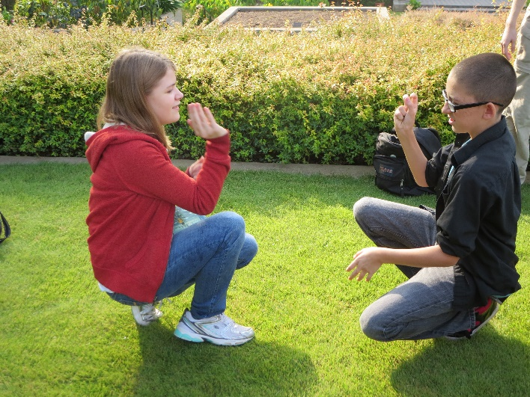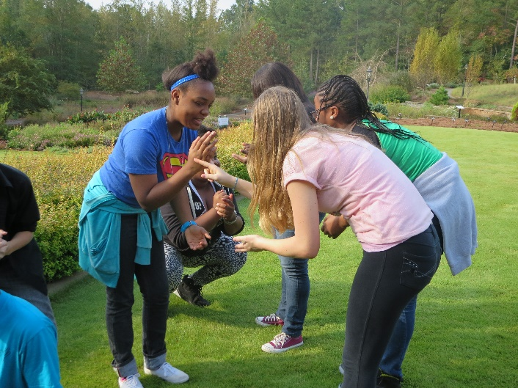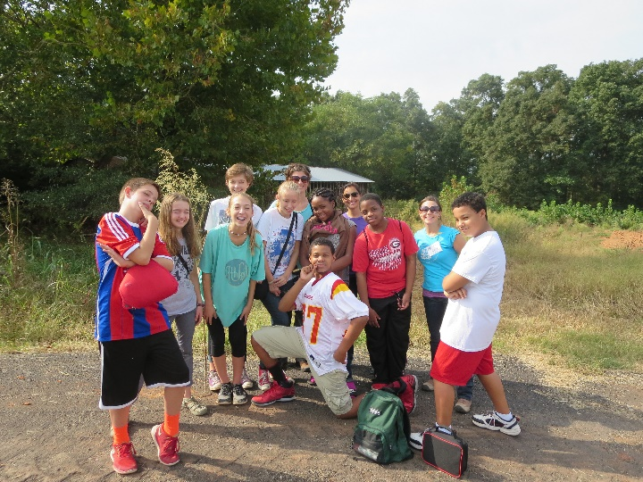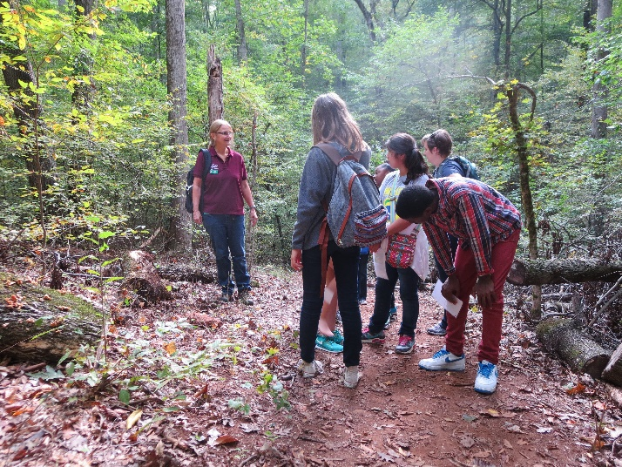**Forest Ecology & Ecological Succession**

Learners will ‘read the landscape’ while investigating biodiversity and change in natural systems at the State Botanical Garden of Georgia. This field experience addresses Georgia Performance Standards and Habits of Mind while learners are immersed in a Georgia Piedmont forest ecosystem. Suggested pre and post visit activities further link the field experience to Clarke County School District‘s 7th grade curricula objectives.

“*If we want children to flourish, to become empowered, then let us allow them to love the earth before we ask them to save it.”* David Sobel, *Place-Based Education: Connecting Classrooms and Communities*



**7th Grade Field Trip, Athens Clarke County School**

**INSTRUCTIONAL MANUAL**

**CONTENTS**

1. **OVERVIEW** p. 3
2. **A CLOSER LOOK AT THE BOTANICAL GARDEN FIELD TRIP** p. 4
   * 1. Georgia Performance Standards
     2. Habits of Mind
     3. Essential Questions
     4. Major Concepts
3. **OUTLINE OF LEARNING EXPERIENCES** p.5
   * 1. Pre-trip Activities
     2. Field-trip Activities
     3. Post-trip Activities
4. **ASSURING SUCCESS FOR THE FIELD EXPERIENCE**
   1. Logistics: Schedule for Field trip, Parking. Etc. p.6
   2. What to Wear, Safety Concerns & More
5. **PRE-TRIP ACTIVITIES**
6. Pre-trip Student Survey p.7
7. Who Am I? p.9
8. Forest Succession: YouTube video p.11
9. Biodiversity Counts I p.13
10. Wake Up Little Birdie! P.16
11. **FIELD TRIP ACTIVITIES**
12. Succession ‘Ro Sham Bo’ p. 17
13. Fox! p. 19
14. Chipmunk and Squirrel p. 20
15. Sit Spot p. 21
16. Discovery Hunt p. 22
17. Biodiversity Counts II p. 28
18. **POST TRIP ACTIVITIES**
19. Create a Succession Plot p. 31
20. Environmental Editorials p. 33
21. Biodiversity Counts III p. 37
22. Post Trip Student Survey p. 40
23. Teacher Critique Form p. 42
24. **ADDITIONAL OPPORTUNITIES**
    1. ‘Connect to Protect’ p. 43

A school site habitat restoration project

**‘Experience UGA’**

**Forest Ecology & Ecological Succession**

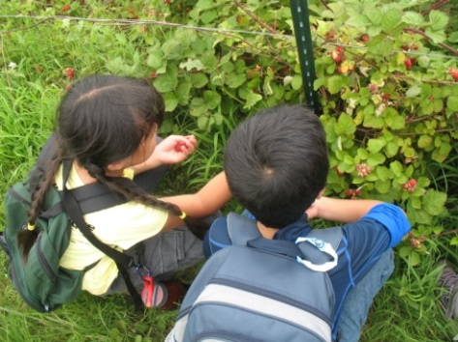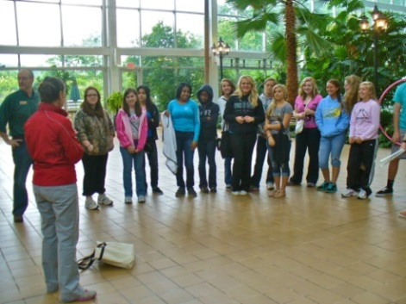**7th Grade Field Trip, Athens Clarke County School District**

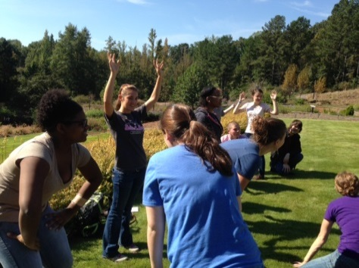

**I. OVERVIEW** The State Botanical Garden of Georgia, in collaboration with the UGArden, is pleased to pilot a field trip program for Athens-Clarke County 7th grade students. Each of these facilities will serve as an outdoor classroom where students can discover how people interact with nature and what nature provides for them. More specifically, while at the State Botanical Garden, 7th graders will learn about Georgia forest ecosystems, biodiversity and ecological succession at the Botanical Garden. Students will be divided into groups of approximately 15 students each, and a Botanical Garden field teacher will lead each group through a series of hands-on science activities.

A week or two prior to the field trip, Botanical Garden field teachers will be available to visit 7th grade classes for pre-trip sessions introducing concepts, activities and procedures relevant to the field trip. During the Botanical Garden portion of the program, students work as scientists and curious naturalists, while hiking through a hardwood forest from the Botanical Garden to the UGArden. Furthermore, students will use a variety of scientific tools and participate in hands-on activities including a biodiversity count, an ecological succession activity, a predator prey game, discovery hunt and more.

While a major goal of the field experience focuses on addressing relevant Georgia Performance Standards, Common Core and related Habits of Mind, an underlying goal lies in exposing students to nature as they walk through and explore a Georgia hardwood forest. A growing body of scientific evidence identifies positive correlations between experiences in nature and student’s ability to learn and develop healthy bodies and minds. The term “nature deficit disorder” was coined by Richard Louv in his book, *Last Child in the Woods: Saving our Children from Nature Deficit Disorder* (2008). Louv, along with leading health professionals, have linked children’s sedentary and indoor lifestyles to some of the most disturbing youth trends, including rises in obesity, attention disorders, and depression. Our proposed Forest Ecology and Ecological Succession program will help students develop a love and curiosity for nature that can begin to foster healthy lifestyle choices.

**BOTANICAL GARDEN CONTACTS**

Berkeley Boone, Children’s Programs Manager [bwboone@uga.edu](mailto:bwboone@uga.edu) (706) 583-0894

Anne Shenk, Director of Education [ashenk@uga.edu](mailto:ashenk@uga.edu) (706) 542-6158

An optional follow-up stewardship project involves developing a ‘Connect to Protect’ habitat on your school site. In this project, students will plant a native garden on their school grounds as part of a conservation effort spearheaded by the Botanical Garden’s Conservation Department. This garden will provide vital pollinator and wildlife habitat in your school yard as well as serve as a great teaching garden for many different purposes! See the brochure on page 41 for more information.

**II. A CLOSER LOOK AT THE BOTANICAL GARDEN FIELD TRIP**

1. **7th Grade Georgia Performance Standards—Science**

* S7L1- Students will investigate the diversity of living organisms and how they can be compared scientifically
* S7L4- Students will examine the dependence of organisms on one another and their environments

1. **Habits of Mind**

* S7CS1. Students will explore of the importance of curiosity, honesty, openness, and skepticism in science and will exhibit these traits in their own efforts to understand how the world works.
* S7CS4. Students will use tools and instruments for observing, measuring, and manipulating equipment and materials in scientific activities.
* S7CS5. Students will use the ideas of system, model, change, and scale in exploring scientific and technological matters.
  + a. Observe and explain how parts can be related to other parts in a system such as predator/prey relationships in a community/ecosystem.
* S7CS6. Students will communicate scientific ideas and activities clearly.

1. **Essential Questions**

* What is an ecosystem?
* What is biodiversity?
* What is ecological succession?
* What is the relationship between maintaining ecosystems, ecological succession and biodiversity?

1. **Major Concepts** The forest is an ecosystem that evolves over time through a process called ecological succession. Students will learn to “read the landscape” in order to find natural clues that illuminate the land use history and its effects on the forest ecosystem. The following are major concepts that students will learn and/or experience during the field trip program:

* The Forest Ecosystem is a wooded habitat that is comprised of producers, consumers and decomposers. Producers are organisms that create their own food from solar energy. Consumers are organisms that obtain food from other sources, and decomposers break down dead material back into soil. This system is a self-sustaining nutrient cycle.
* Ecological Succession is the sequence of organisms that occupy an ecosystem over a period of time. Disturbances such as agriculture, flood, and other natural disasters create a vacuum within an ecosystem and an abundance of sunlight. Sun-loving herbaceous plants first fill the void, followed by sun-loving trees, and then shade tolerant tree species. These plant species occupy the forest in a predictable order that is scientifically documented.
* Species Richness is a measurement of how many different species occupy a specified study area within an ecosystem.
* Density is a measurement of how many total plants occupy a specified study area within an ecosystem.
* Throughout the 4 hour field trip program, students will be completely immersed in nature, experiencing the Georgia Piedmont forest and a small vegetable farm. Recent research that has been synthesized by Richard Louv in his book Last Child in the Woods demonstrates that regular time outdoors is essential for both physical and mental health, particularly in developing children. This field trip will provide ample outdoor time, physical activity, and many new experiences for Clarke County 7th grade students, exposing them to healthy lifestyle choices.

**III. OUTLINE OF LEARNING EXPERIENCES**

**A. Pre-Trip Activities:** Botanical Garden field teachers are available to lead these activities one to two weeks prior to the field trip. Please Contact Berkeley Boone to schedule a pre-trip visit (see contact information on page 1). Alternatively, the CCSD teachers can lead the activities and introduce the field trip procedures. (see Section IV)

1. *A Pre-trip Survey* that polls students about their experiences in and knowledge of the forest ecosystem.
2. *‘Who Am I?’-* Students learn about a variety of organisms (on eco-service cards provided with the pre-trip packet) that are a part of the forest ecosystem, and classify them as producers, consumers or decomposers as well as describing their role (niche) in the forest ecosystem.
3. View a *YouTube video about forest succession* with questioning strategy.
4. Participate in an introductory ‘*Biodiversity Count’* mini-lesson.
5. Create a biodiverse bird chorus ‘*Wake Up Little birdie!* - from the Aldo Leopold Project.

**B. Field Trip Activities:**

1. *Succession ‘Ro Sham Bo’-* from ABCs of Ecology. Students participate in a role-playing game that teaches about forest succession.
2. *Forest Plot Biodiversity Studies*- students study plant species richness and density in two different 10x10 foot plot studies in the forest. Through their findings and observations students will discuss what ecological and human factors might have influenced the ecosystem to create these different plant communities. (i.e. a tree falling over in a storm allows more sunlight to come down to the forest floor so there is a patch of sun-loving herbaceous plants).
3. *Forest Discovery Hunt* – throughout the field trip, students will work in pairs on a discovery hunt that teaches about land-use history, plant ID, and biodiversity.
4. *‘Fox’-* from ABCs of Ecology. Predator-prey game that can be played in a variety of different areas along the hike that demonstrates how different habitats provide varying amounts of cover for animals to hide from predators. This activity allows students to think about the forest from the perspective of an animal.
5. *Sit Spot with reflection questions*— Students will use the last 5-10 minutes of the field trip to sit in their own space in the forest and answer questions about the field trip as well as open ended questions about their experience being in the forest. (if time permits)

**C. *Post-Trip Activities:***

1. *‘Create a Succession Plot’-* Students and Teachers will rope off an area on their school site where they will study the plants as they grow up into a field and a young forest over time.
2. *‘Environmental Editorial’-* Students will read an article about a fictional town that has a logging company come to town. They will then assume the role of different interest group and write an editorial from that perspective.
3. ‘*Biodiversity Count’*- Students will conduct a biodiversity count on their school site using the same procedures modeled during the field trip.
4. *Post trip Student Survey and teacher critique form*

**IV. ASSURING SUCCESS**

1. **Logistics: Schedule for Field trip, Parking. Etc.**

**9:30—Students Arrive**

* 3 buses total with approximately 110 students—55 students will start at UGArden and 55 students will start at the Botanical Garden
  + One bus to UGArden (about 40 students)
  + One bus to Botanical Garden (about 40 students)
  + One bus drops half students first at Botanical Garden, then second at UGArden (15 students at each location)
  + 2 buses parked at UGArden, 1 bus parked at Botanical Garden (see map)

**9:40—11:10** Students are taken through field trip activities at their respective sites (55 at Botanical Garden and 55 at the UGArden)

**11:15—11:45** All 110 students meet at UGArden for picnic lunch in the amphitheater

**11:50- 1:20** Students switch to complete the second half of their field trip

**1:30** Students get on buses to go back to school.

* One bus at the Botanical Garden takes about 40 students
* Two buses are a the UGArden (40 students on one, 15 on the other)
* The bus with 15 students swings by the Botanical Garden to grab the remaining 15 students

1. **What to Wear, Safety Concerns & More**

We aim for each group to get the most out of their experience at the Botanical Gardens. Please read and **share the following guidelines with** **all adults and students** prior to your trip.

* Please make sure that ALL students and chaperones wear closed toe shoes for hiking through the woods from the Botanical Garden to the UGArden (about 1.5 miles). Most of the terrain is level but parts are slightly hilly. Long comfortable pants are advised as vegetation is high in places.
* While outside on the trails, our experienced Field Teachers will be leading students through hands-on, educational activities. Many of these will require *getting dirty and handling live creatures*. **Please** allow your students to engage in these sensory activities for themselves by kindly checking your own fear of dirt, snakes, worms and spiders at the door.
* We will reschedule your field trip programs for inclement weather (i.e. pouring rain or a thunderstorms). However, it is important that students are dressed appropriately for outdoor activities: **close-toe shoes, please!**
* In order to get the most out of their experience, students should listen carefully to their field trip leader’s directions. It is expected that teachers address discipline issues that may arise. We also ask that teachers and chaperones to work with small groups of students after instructions are provided by the field trip leader.
* You may not pick any plants.
* We will start the field trip at a trail head; restrooms will not be available until the end of the field trip so please allow times for students to use facilities at school prior to driving to the botanical garden. Porta potties will be available at the UGArden.
* Students will eat lunch at the UGArden. Logs and or hay bales will be available as seating. Please make sure that the school lunches are on the buses that will be parked at the UGArden.
* **Most importantly, have fun!**

**EXPERIENCE UGA: Forest Ecology and Ecological Succession Field trip**

**The State Botanical Garden of Georgia – Pre-trip Inventory**

Name _________________________________________ I am: Male Female (circle one)

**Section 1**: We want to know what you think about some things. There are no right or wrong answers. Just be honest about the way you feel. After I read each sentence, you will see five choices: Strongly Disagree (two thumbs down), Disagree (one thumb down), Not Sure (question mark), Agree (one thumb up) and Strongly Agree (two thumbs up). Circle the one that best describes how you feel about each statement.

*Example Statement:*

|  |  |  |  |  |  |
| --- | --- | --- | --- | --- | --- |
| 1. I like pizza. | Strongly Disagree  👎👎 | Disagree  👎 | Not Sure  ? | Agree  👍 | Strongly Agree  👍👍 |

Questions? I’ll read one sentence at a time and you decide how you feel about each one. Raise your

hand if you need help.

|  |  |  |  |  |  |
| --- | --- | --- | --- | --- | --- |
| 1. I like hiking in the forest. | Strongly Disagree  👎👎 | Disagree  👎 | Not Sure  ? | Agree  👍 | Strongly Agree  👍👍 |
| 2. I can investigate science and learn important concepts while outside in the woods. | Strongly Disagree  👎👎 | Disagree  👎 | Not Sure  ? | Agree  👍 | Strongly Agree  👍👍 |
| 3.I know a lot about the plants and animals that live in the woods. | Strongly Disagree  👎👎 | Disagree  👎 | Not Sure  ? | Agree  👍 | Strongly Agree  👍👍 |
| 4. I am afraid of forests that are full of plants, insect and other animals. | Strongly Disagree  👎👎 | Disagree  👎 | Not Sure  ? | Agree  👍 | Strongly Agree  👍👍 |
| 5. Humans have changed Georgia forests. | Strongly Disagree  👎👎 | Disagree  👎 | Not Sure  ? | Agree  👍 | Strongly Agree  👍👍 |
| 6. Biodiversity helps keep a forest healthy. | Strongly Disagree  👎👎 | Disagree  👎 | Not Sure  ? | Agree  👍 | Strongly Agree  👍👍 |

**Section 2**: Good job. Now, we want to find out what you already know about Georgia forests. For each question, circle the answer choice you think is right. Your answers will help us plan interesting activities.

1. Ecological Succession or change in the forest is caused by:

a) tornadoes

b) farmers

c) dead trees

d) all of the above

2. Species Richness is

1. the dollar value of a plant or animal
2. the nutrient value of a plant or animal
3. a measurement of how many different species occupy a specified area within an ecosystem
4. none of the above

3. Which of these living things produces its own food?

1. grasshopper
2. sunflower
3. catfish
4. eagle

4. Which techniques can be used to investigate biodiversity?

1. insect pitfall trap
2. 10 x 10 foot plot study
3. soil color
4. all of the above

5. Species density is:

1. The weight of a species
2. A measurement of the total plants in an area within a forest
3. A specie’s position in the ecosystem
4. A specie’s position in a food chain

**Section 3**: Complete the following task to the best of your ability. A forest ecosystem includes many components. Draw or list as many as you can think of in the box below. If you prepare a drawing, label some of the items that you include.

**Who Am I?**

**Objectives:**

*Learners will*

1. Define the terms producer, consumer and decomposer.
2. Identify several key species of the GA Piedmont forest.
3. Understand how organisms function together in a forest ecosystem.

**Skills:** creating hypotheses

**Supplies:**

* Tape
* One set of eco-service cards

**Subjects:** science

**Time:** 20 minutes

**Location:** indoors or outdoors

**Essential Questions:**

*Who are the plants and animals that are living in the Georgia Piedmont forest ecosystem?*

*What are producers, consumers, and decomposers?*

**Background Information:**

The Georgia Piedmont forest is a unique wooded habitat that is comprised of many plants and animals that rely on each other for food, shelter, and space. Producers are organisms that create their own food from solar energy. Consumers are organisms that obtain food from other sources, and decomposers break down dead material back into soil. This system is a self-sustaining cycle. In the Georgia Piedmont forest, these organisms are specifically adapted to survive in north Georgia’s climate and soil, and each organism has multiple functions within the ecosystem. For example, the Eastern Redbud tree is an understory tree that is able to make use of the low sun levels in the mid-level of the forest; its roots stabilize the soil and its fallen leaves are broken down by decomposers to provide nutrients for the soil. It also produces bean pods in the fall that are a food source for birds and deer.

**Procedure:**

1. Hand out the eco-service cards to your students. Have each student read their card aloud to the class so that all students are familiar with each of the organisms.
2. Collect the cards, and have students stand up in a circle. Tape a species card to each student’s back, and be sure to let them know that they are not allowed to tell their friends which card is on their back.
3. Have students mingle around the room and play 20 questions (with yes or no questions) until they identify the organism that is taped to their back. Students ask questions about their own organism to other students in the class.
4. Once all students have correctly guessed the card that is taped to their back, introduce the concepts of producers, consumers and decomposers and what their jobs are in the forest. Have the class break into three groups by whether they are a producer, consumer or decomposer and answer the discussion/assessment questions below.

**Discussion/Assessment:**

* What does your group of organisms contribute to the forest ecosystem?
* If a disease came through and wiped out all the organisms from your group, what would happen to the forest ecosystem?
* In what way do the other two groups of organisms rely on your group?
* Can any of the three groups survive without the other two?

**Forest Succession: Old-Growth & New-Growth Forests**

**Questions:**

**Objectives:** *Learners will*

1. Distinguish between Old-Growth and New-Growth forests.
2. Describe the terms biodiversity, species richness and species density.

**Supplies:** Video projection system

http://www.youtube.com/watch?v=lSO4BgOJynMEssential

**Subject:** Science

**Time:** Video – 7 minutes

Discussion – 5 minutes

**Location:** Classroom

*What is an old-growth forest? a new-growth forest?*

*What is species richness?*

*What is species density?*

*What disturbances might disrupt the process of succession?*

**At a Glance:**

Students will view a YouTube Video about ecological succession that illustrates the difference between old-growth and new- growth forests and will reflect on what they learned through a follow-up discussion. While the video depicts a forest in Northwoods, Wisconsin, the concepts can be generalized to Georgia forests.

**Background Information:**

A basic concept in environmental science is succession, which is the regular pattern of changes in the types of species in an ecosystem. While people tend to think of forests as static, they are constantly changing over time. These changes follow generally predictable patterns. Scientists study these patterns to learn how a forest grows and to understand more about how human interference is changing ecosystems. Because resources in an ecosystem are limited, organisms are constantly engaged in a battle to win the resources that they need for growth. Different organisms have adopted different techniques to take advantage of resources. Since the forest is constantly growing and changing, tactics that provided an advantage at one point may not be as advantageous later. For instance, some species of trees grow quickly with lots of sunlight. Once they have grown however, their own shade makes it difficult for their own offspring to survive. Other trees are better adapted to growing seedlings in shady conditions and eventually grow to crowd out the first group of trees.

An **old-growth forest** (also termed primary forest, virgin forest) is a forest that has attained great age without significant disturbance, and thereby exhibits unique [ecological](http://en.wikipedia.org/wiki/Ecological) features and in some cases may be classified as a [climax community](http://en.wikipedia.org/wiki/Climax_community).[[1]](http://en.wikipedia.org/wiki/Old-growth_forest#cite_note-1) Old-growth features include diversity of tree-related structures that serve as diversified wildlife habitat which lead to higher biodiversity of the forested ecosystem. A **new-growth** forest is a young forest that is going through change or ecological succession as it progresses from an ecosystem dominated by grasses, wildflowers and shrubs to an ecosystem of evergreen and hardwood trees.

The video also introduces the terms species density and species richness.

* **Species Richness** is a measurement of how many different organisms occupy a specified study area within an ecosystem.
* **Density** is a measurement of how many total plants occupy a specified study area within an ecosystem.

**Getting Ready:**

Access the YouTube video: http://www.youtube.com/watch?v=lSO4BgOJynMEssential

**Procedure:**

1. Show Video Clip

2. Discussion questions:

* What is an old-growth forest? A new-growth forest?
* In what ways are these two forests different?
* Which is easier to locate- a new-growth or an old-growth forest?
* How do forests change from old-growth to new-growth forests?
* What is biodiversity? species richness? and species density?
* How does nature make opportunities for new-growth forests in ecosystems?

**Biodiversity Counts!**

State Botanical Garden of Georgia

# 2450 S. Milledge Avenue

**Essential Questions:**

**Objectives:** *Learners will*

1. define the term biodiversity.
2. describe how biodiversity can be measured.

**Skills:** recording data, inference, answering own questions, analysis

**Supplies:**

* Biodiversity Counts! Datasheet
* pencils
* ‘Habitat bags’
* elbow macaroni
* Spiral macaroni
* Pennies
* dried beans
* rocks

**Subjects:** science, math

**Time:** 20 – 30 minutes

**Location:** indoors

*What is biodiversity?*

*How do scientists measure “species richness”?*

*How do scientists measure “density”?*

**At A Glance:** This activity helps students understand how to measure species richness and abundance prior to completing a biodiversity plot study during the Forest Ecology and Ecological Succession field trip program.

**Getting Ready**

Prepare 4-6 different “habitat” bags before class by placing “species” in a plastic Ziploc baggie. “Species” are pennies, pasta, rocks, etc. Each bag should have a different combination of species. For example, one bag has many of one species less of the others, another bag has a few of each species, and one habitat bag should be prepared with just one species to represent a pine plantation monoculture.

**Background Information:**

Bio means ‘living’ and ‘diversity’ is variety. So when ecologists measure biodiversity they are studying the variety of organisms in an ecosystem. A biologically diverse ecosystem, such as a Georgia Piedmont forest, is healthy, complex and stable. Even though nature tends to increase diversity through the stages of succession recent research in ecology indicates that maturity may not represent the stage with the greatest diversity, at least in terms of species. Rather, the greatest diversity is when a system approaches maturity; with diversity declining slightly thereafter as full maturity is attained. Forests with many successional stages provide the greatest overall diversity.

A monoculture is the growth of one species in an area such as a pine plantation or a wheat field. All the species are identical which supports very few other organisms. Disease can spread quickly through a monoculture; therefore, herbicides and pesticides are needed to maintain them.

A way to study the biodiversity of an area is through a process called “plot sampling,” where scientists use a designated sample size (such as a 10x10ft square) and quantify the number of species contained within that square. The number of different species within the sample area is called “species richness” and the total number of organisms is called “density.”

On the field trip program at the Botanical Garden, students will be studying and quantifying a variety of 10x10ft plots throughout the forest ecosystem. The activity described below is a way for students to practice measuring species richness and diversity in the classroom before going out in the field.

**Procedure**

1. Introduce the term “biodiversity” to learners as referring to a variety of life. Bio means ‘living’ and ‘diversity’ is variety. So when ecologists measure biodiversity they are studying the variety of organisms in an ecosystem. Scientists quantify biodiversity in a measure called “species richness,” which refers to the number of different species in a designated area.
2. Divide learners into 4 to 6 scientist teams. Assign the team a number and give each team a “habitat” bag with “species” inside.
3. Ask scientist teams to choose a recorder and give each team a Biodiversity Counts! worksheet, a 10x10ft square and a pencil.
4. Have each team pour out the contents of their bag onto the square that is drawn on the worksheet—this is meant to represents the 10x10ft plot that students will be working with out in the field. Ask teams to work together to count the different species and record the numbers on the worksheet.
5. Using the Biodiversity Counts! Key, team recorders will write down the names and numbers of species and tally them. The key is used to help learners know what to call the species and also gives them good practice in using reference materials. Tell learners that scientists often use keys called field guides to help them identify species that they have observed. In the key, each penny, rock, pasta, etc. stands for a specific species. For example—pennies stand for Loblolly Pine. Learners should write “Loblolly Pine” in the species column of the worksheet and the number of them in the second column. Teams should tally the numbers of individuals and write the total in the gray box (the last row).
6. After all teams have counted and recorded their species, ask a member from each team to report to the class what species they found in their habitat and what their species richness was. Have each team record their chart on the board.
7. Conclude the activity by asking learners the discussion/assessment questions below.

**Discussion/Assessment**

* Which habitat was the most diverse?
* Which habitat had the highest density of plants?
* If a caterpillar came through your habitat and fed on and killed all of the Loblolly Pines, which habitats would survive?
* If you were a squirrel, which habitat would you like to live in?
* Which habitat would be able to support the most diverse animal population?

Biodiversity Counts! Datasheet

Biodiversity means a variety of life. Count the species in your bag habitat and record the species richness (number of different species) and abundance (total number of organisms) in the gray boxes at the bottom of the chart.

|  |  |
| --- | --- |
| Name of Species | **Number in your habitat** |
|  |  |
|  |  |
|  |  |
|  |  |
|  |  |
|  |  |
| Species Richness  Number of different species |  |
| Density  total number of organisms |  |



**Species Key:**

Goldenrod

Grape Vine

Loblolly Pine

Red Oak Tree

Hickory Tree









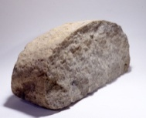

**Biodiversity Counts!**

**School Site Biodiversity Count**

10 Feet

10 Feet

**Wake Up Little Birdie!**

**Objectives:** Learners will

1. Identify different bird calls that are part of the dawn chorus.
2. Understand a different technique for quantifying species richness.

**Skills:**

**Supplies:**  Bird cards

**Subjects:**  science

**Time:** 10 minutes

**Location:** Indoors or Outdoors

**Essential Questions:**

*What birds sing during the dawn chorus?*

*What is a way that scientists measure bird biodiversity?*

**Background Information:**

Aldo Leopold was a famous environmentalist, ecologist and author who is best known for his book A Sand County Almanac. Throughout his career as an ecologist, he often listened to the morning chorus of birds, and to this day his notes on the subject have helped ecologists study the biodiversity of birds. Most recently, scientists have attempted to recreate the “sound-scape” of the dawn chorus as it would have near University of Wisconsin, Madison, where he lived and studied the birds and compare it to the current sound-scape in the same location. This has allowed ornithologists and ecologists to take a listen (instead of a look) at how bird species biodiversity has changed over time. The following activity allows students to recreate the dawn chorus and learn the calls of some of our local birds.

**Procedure:**

1. Divide students into 12 groups and assign each group a bird card with the mnemonic information printed on the card. Have each group practice their bird call.
2. Then have students line up according to the time on their card and have the first group (field sparrows) start their call.
3. Have each successive group wait about 10 seconds and then join in with their call as well—each group keeps on calling while the others join in.
4. Pretty soon, the classroom will be filled with the sounds of many different bird calls.
5. Once the last bird has joined in, allow the calls to keep going for about 15 seconds. Then have all the students stop.
6. Conclude the activity with the following discussion/assessment questions.

**Discussion/Assessment:**

*If an ecologist is studying biodiversity of birds (as compared to plants) what techniques might he/she use to determine the species richness?*

**Succession Ro-Sham-Bo**

**Location:** Outside

**Objectives:** *Learners will*

1. Identify the stages of forest succession
2. Discover the plants that are characteristic of each succession stage
3. Understand the impact of human and natural disturbances on forest succession.

**Supplies:** none

**Subject:** Science

**Time:** 10-15 minutes

**Essential Questions:**

*What are the stages in forest succession?*

*What natural and human disturbances might affect the process of succession?*

**At a Glance:**

Students will learn about the stages of plant succession in a forest ecosystem.

**Background Information:**

Succession is the natural process in which one plant community is replaced by other over time. Initial succession plant communities are comprised of sun loving, low-growing plants such as grasses and woody shrubs. Within 15-25 years, fast growing trees such as pines grow to create a forest, shading out the sun loving grasses and shrubs. Then, over the next 100 years, shade-tolerant hardwood trees will begin growing amongst the pines, eventually out-competing them. Shade-tolerant, ground cover plants will also begin growing along the forest floor. During the hike portion of the field trip program, students will observe and study these different succession stages.

**Getting Ready:**

This game should preferably take place in an outside location where example plants can be seen (golden rod, pine, red oak). If these plants are not available, use pictures.

**Procedure:**

1. Explain the directions to the students. The game follows like rock-paper-scissors. All students start squatting, as golden rod.
2. Students play rock-paper-scissors with the winner, succeeding to become a pine tree. Pine trees hunch over since they are taller than grasses. The loser remains a golden rod and continues to play with other golden rods.
3. The new pine trees play rock-paper-scissors with other pine trees. The winners in these rounds succeed to become red oaks, which stand up straight and tall. The losers remain pine trees and continue playing with each other.
4. Eventually, most students will become red oaks. As an alternate, to prevent this, have the losers from each round return to being a golden rod.
5. As the forest “grows up” with a large number of red oaks, the teacher may choose to introduce a natural disaster such as a fire or tornado and knock down most of the trees—who then return to being a golden rod plant. The game can then continue.
6. Periodically stop the game and discuss with the students about what stage of succession their forest is currently in.

**Discussion/Assessment:**

*How might different disturbance affect the succession of plant communities? Consider a clear cut or fire versus a tornado.*

*How does succession affect the diversity of an ecosystem?*

*What are some early and late succession plant species?*

*Can you identify what stage of succession the nearby forest is in?*

**Fox!**

**Essential Questions:**

*How do animals use their habitats to help them avoid predation?*

**Location:** Outside

**Objectives:** *Learners will*

1. Understand predator-prey relationships.
2. Learn that habitats can affect the success of different predator and prey species.

**Skills:**

**Supplies:** none

**Subject:** Science

**Time:** 10 minutes

*What components of a habitat are important to the predator-prey relationship?*

**At A Glance:**

Students will learn about predator-prey relationships and how they are affected by habitat.

**Background Information:**

Predator-prey relationships are an important force in every ecosystem! To survive in the wild, both the predator and the prey must have adaptations. Predators must be quick and have excellent senses to detect their prey. Prey must be quick to escape from their predators and have the ability to hide. Both predators and prey may have different adaptation to help them survive depending on the habitats they live in. By playing this game, students will better understand how an animal’s habitat affects its ability to survive!

**Getting Ready:**

Very little is needed in preparation for this game. Identify several locations for the playing of this game. Ideally locations should demonstrate different habitats (ex: forest, edge, and field) Explain the directions of the game to the students.

**Procedure:**

1. Explain the directions of the game to the students. The students will be the prey (rabbits) and the teacher will be the predator (fox).
2. The teacher yells “Fox!” and students are to run and hide from the predator. The teachers closes his/hers eyes while counting to 10.
3. The teacher opens his/hers eyes and calls out the names or clothing color of the students he/she sees.
4. Once all the visible rabbits have been called out, the teacher yells “carrot!” and the remaining students peek out from their hiding spots. The student that is closest to the teacher wins.
5. Repeat game at random without warning the students in different habitats.

**Discussion/Assessment:**

*Which habitat provided the easiest hiding places?*

*As a rabbit, which habitat would be best to avoid predators? What about a squirrel? A bird?*

*How would different animals hide from predators in a variety of habitats?*

*What other factors influence an animal’s habitat choice?*

**Chipmunk and Squirrel**

*Adapted from the ABC’s of Ecology*

**Background Information*:*** Squirrels and chipmunks have evolved to cache their food differently in preparation for winter. Chipmunks cache all of their food in one place, while squirrels hide a bit here and a bit there. Students in this activity will get to act out these different behaviors and see whether one caching behavior is more beneficial than the other.

**Location:** Outside

**Objectives:** *Learners will*

Compare the food storage (caching) behavior of chipmunks and squirrels

**Supplies:** enough dried beans for each student to have 9 beans

**Subject:** Science

**Time:** 20 minutes

**Directions*:***

* + - 1. Divide students into two groups, the gray squirrels and the chipmunks. Each squirrel receives 8 beans, representing acorns they have collected for winter. Their first task is to venture away from the "nest" and hide their food (chipmunks hide it all in one location, and squirrels in a few different locations) Delineate some boundaries and give the chipmunks and squirrels thirty seconds to go out and stash their food. That accomplished, they are going to have to survive the winter.
      2. There are three rounds to the game: December, January, and February. During each round, the squirrels need to collect three beans in order to survive. They will be given 31 seconds (one second per day of the month to collect their beans). You can simply count aloud or actually time them (28 seconds for February because there are only 28 days).
      3. This task will obviously become more difficult as the game proceeds because no one squirrel has cached enough acorns to survive on their own. Some students will return to the nest after the first round and proudly present to you a whole handful beans (possibly their entire cache). You should point out that that squirrel is now wonderfully fed for the month of December but still has to survive the rest of the winter. Let the game play out as it will ... the squirrels might have to learn lessons the hard way. Remind students that they can take any beans they find-they are not limited to their own beans.
      4. There will be rounds when students return to the nest without having found any acorns. Allow them one round of not finding any, but give them a handicap for the next round. Possible handicaps include having to hop around on only one foot, or having to hold onto their ankle with one hand while they make their way around. If the same student does not find acorns two rounds in a row, they unfortunately have to die- many students enjoy acting out a dramatic death scene.

**Discussion/Assessment*:***

*How did the different strategies work out?* Were *there* *advantages to* one *over the other?*

There are advantages and disadvantages to the behavioral strategies of chipmunks and squirrels. For chipmunks who hide all their acorns in one cache, there is the advantage of only having to remember one location, but on the flip side, if another animal were to happen upon the cache they'd have found a jackpot of acorns! When squirrels hide their acorns in different locations, they have more to remember, but less to lose if another animal finds a stash.

*What happens to the acorns that the squirrels couldn’t locate?* They turn into oak trees!

**Sit Spots**

*Adapted from Coyote’s Guide*

**Essential Questions**

*What do we notice when we sit quietly in nature?*

**Background Information:**

“Sit spots” or “magic spots” in the woods help students tune into nature and learn to relax in the woods. When introducing this activity, be sure to inspire people. Tell a story of your own experience sitting out in nature or ask them if they'd like to be able to see or touch a wild animal.

**Directions:**

* + - 1. Find a Spot. Wherever you are, ask the participants to go out and find a Sit Spot where they will sit still and quiet and wait to see what they notice. Ask them to Fox­ Walk to fin d a spot that calls to them in the nearby area. You can take a group along a path and let individuals veer off one by one, or delineate boundaries from your starting point. Keep everyone at least in earshot. Once they find a spot, they will sit as still and quiet as they can, and turn on their Owl Eyes and Deer Ears to see what comes.
      2. Give a Time Limit. Tell them you will call them back in a few minutes, and ask them not to come back until they hear the call. The amount of time you have them sit will depend on your group. Start with an awesome five minutes for five- or six-year-olds; older people might find their initial capacity for sitting still at around *15* minutes. Adults completely vary, but some can easily sit for hours. Expect a wide range of reactions. No matter how long they sit, some will want more, others less.
      3. Return with Story of the Day. Call them back in and ask them what they noticed. Participants will often come back with excited tales to tell of animals they think they heard or butterflies or birds they saw. If the inspiration is alive and flowing in the group, encourage them to find a Sit Spot at home and come back next time to share their stories. A personal Sit Spot story time start a day in a great way. Use this opportunity to role model your own Sit Spot practice. Role modeling our own Sit Spots helps inspire all of us as mentors to keep going to our Sit Spots!

Forest Discovery Hunt

**Essential Questions:**

**Objectives:** *Learners will*

1. Observe the forest habitat for clues that point to the landscape’s agricultural past.
2. Learn about clues that animals leave behind such as footprints and scat.

**Skills:** observation

**Supplies:** Forest Discovery Hunt cards

**Subject:** science

**Time:** ongoing throughout the program

*How can ecological succession give us clues about the history of a forest?*

*What are some major human disturbances that have shaped Georgia forests?*

**At a Glance:**

While students are hiking through the forest, they will be looking for specific animal signs and plant formations that are depicted on their discovery hunt card.

**Background Information:**

Humans have had a major impact on the forested landscape across Georgia, and there are clues that we can look for in the woods that point to our land use history. Old trees that branch out wide amongst a stand of younger trees, barbed wire fences in the middle of the woods, and piles of rocks are a few of the objects that give away that a forest used to be an agricultural field. Furthermore, animals (that we may never see) leave behind scat and footprints that tell us where they have walked or hunted for food. As we start to open our eyes to these subtle changes in the landscape, the forest begins to tell a story that can be read like a history book. Most importantly, the discovery hunt cards invite students to begin looking at the woods as a place to be explored!

**Procedure:**

* + - 1. Hand out a Forest Discovery Hunt card to each student or pair of students in your group at the very beginning of the field trip.
      2. Tell the students to read and become familiar with their cards and that throughout the hike they should be looking for the item that is on their card.
      3. As students find their tree, scat, footprint, etc. have the group stop while the cardholder reads their description and asks the question in italics at the bottom.
      4. See if students can answer the question, and if not, lead them through a series of observation-based questions to see if they can come to a conclusion.
      5. Continue the hunt through the end of the program.

**Discussion/Assessment:**

*Invite students to make observations on their own about the forest that aren’t necessarily on a card. Whenever they notice something interesting in the forest, it’s worth an investigation!*

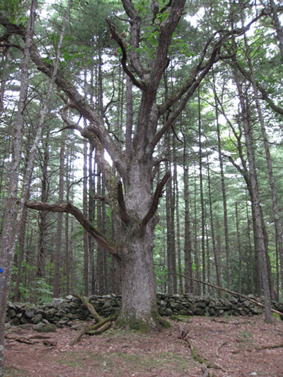Forest Discovery Hunt

The term **Wolf Tree** refers to a large branching tree in the woods that is surrounded by much smaller, younger trees. These trees are evidence that this area was once pasture land and the wolf tree was probably a shade tree for livestock in the middle of a grazing field. *Why do you think the wolf tree branches out while the surrounding trees grow straight up without many lower branches?*

Forest Discovery Hunt

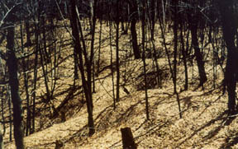

**Pillows and Cradles** are evidence of old fallen over trees. When a tree blows over in a storm, it is uprooted and leaves a large hole in the ground. Over time, the root-ball will decay, leaving a mound of dirt next to the hole—hence a “pillow” and a “cradle.” *If the forest floor is covered in many pillows and cradles, what might have happened?*

Forest Discovery Hunt

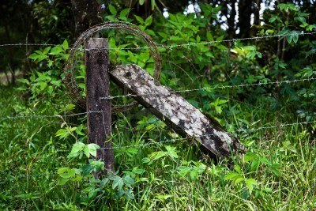

Why might there be a **Barbed Wire Fence** in the middle of the forest? Many of our Georgia forests are old farm fields that have been abandoned and undergone ecological succession over time until they hardly resemble a field anymore*. Can you imagine what this landscape might have looked like with livestock on it and no trees? What kind of livestock might a farmer keep fenced in with barbed wire?*

Forest Discovery Hunt

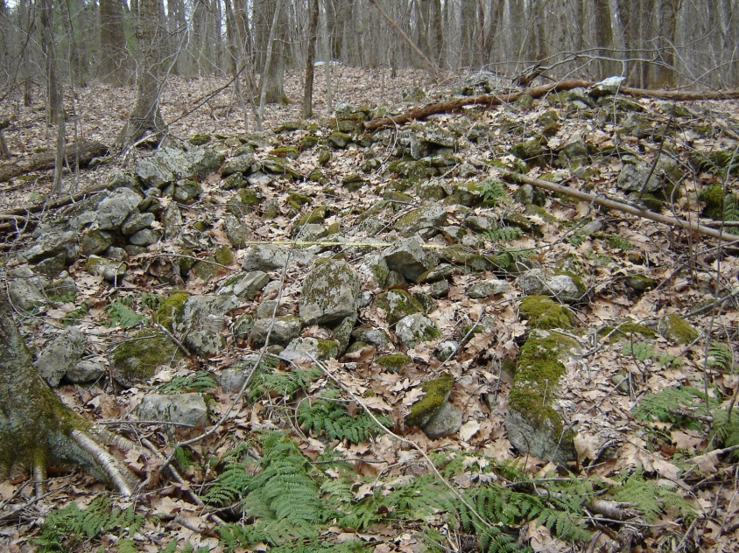

**Rock Piles** are another clue that this forest used to be an agricultural field. When farmers prepare their fields for planting, they often remove any large rocks and pile them in one location. *What is the benefit of a farmer removing rocks from their fields?*

Forest Discovery Hunt

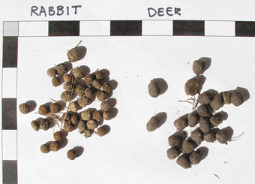

**Scat** is a scientific term for animal poop. On any given walk through the woods, humans tend to scare away the animals that live there, so scat is an important indicator of what animals might be living there. Also, scientists might examine scat in order to learn about the diet of an animal in a particular habitat. *Can you see any animal or plant parts in the scat such as seeds, fur, or bones?*

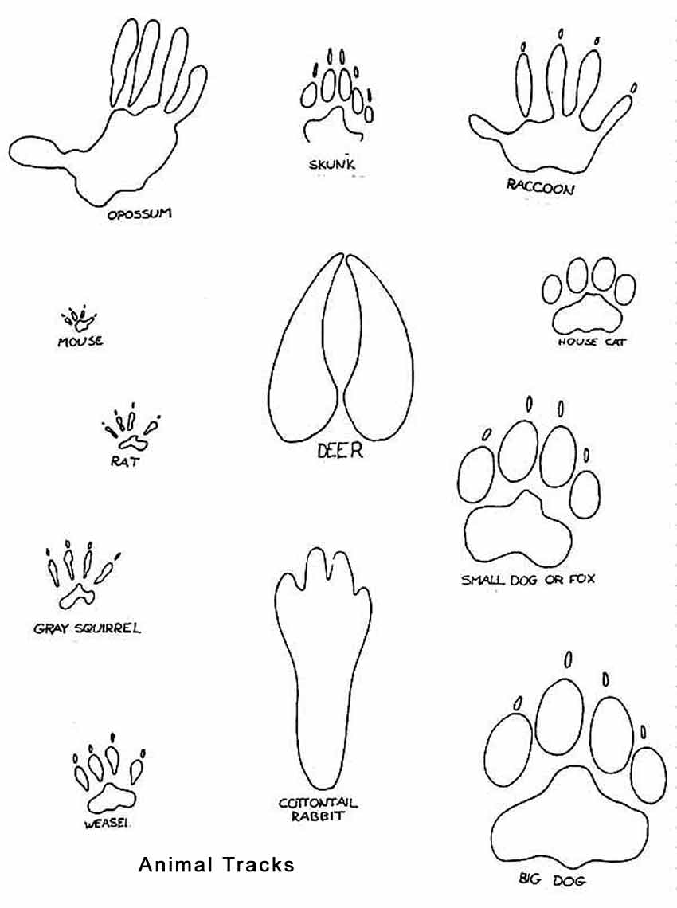Forest Discovery Hunt

**Animal Tracks** are an important piece of evidence to look for when you are in the woods. While you might not see many animals when you are out in the forest, if you keep your eyes peeled you may see some of the clues that they leave behind. *What might be a place that you are more likely to see animal footprints in the forest?*

Forest Discovery Hunt

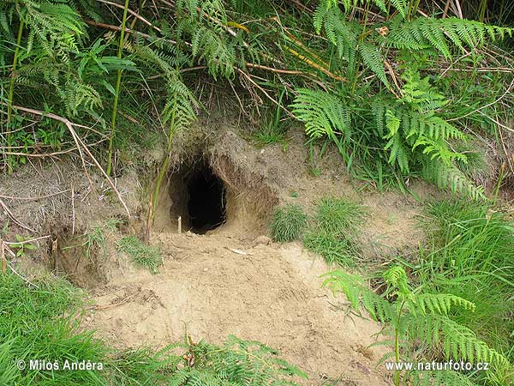

Many forest animals such as foxes, rabbits, chipmunks and armadillos make their homes in **burrows**. Keep your eyes out for these secretive holes in the ground. *What do you think is the ecological advantage for an animal to make their home underground?*

Forest Discovery Hunt

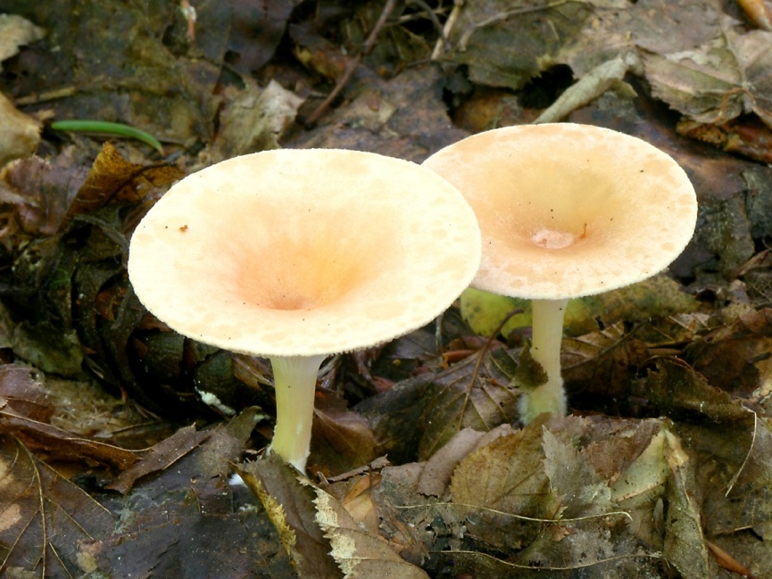

**Fungus** is one of the forest ecosystems decomposers. They break down dead plant matter back into soil, making nutrients available for plants to grow. *What do you think might happen to the forest if there were no decomposers like fungus?*

Forest Discovery Hunt

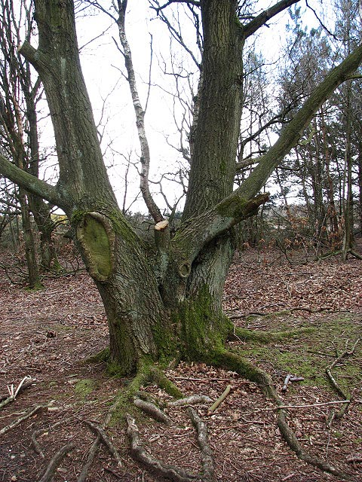

A **tree with multiple trunks** is living proof of some sort of disturbance in the forest. When growing undisturbed, a tree will only have one main trunk. But, if that tree is blown over or cut down, its remaining stump will sometimes send multiple new growth shoots that develop into trunks. *If you wanted to estimate the age of the tree when it was disturbed, what part of the tree would you measure, one of the smaller trunks or around the original base?*

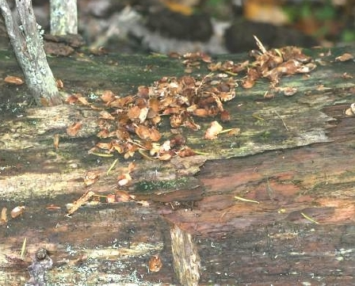Forest Discovery Hunt

**A stash of acorn husks** is evidence of a squirrel or chipmunk meal. Many times you will find these piles of husks on top of a log or rock. *What might be the advantage of a squirrel eating her meal on top of log?*

**Biodiversity Counts II**

State Botanical Garden of Georgia

# 2450 S. Milledge Avenue

**Essential Questions:**

*What is biodiversity?*

**Objectives:** *Learners will*

1. Define the terms biodiversity, species richness and species abundance.
2. Describe how biodiversity can be measured.

**Skills:** recording data, inference, answering own questions, analysis

**Supplies:**

* Biodiversity Counts II Datasheet
* clipboard
* pencils
* air thermometer
* soil thermometer
* soil color cards
* white cloth

**Subjects:** science, math

**Time:** 15 minutes

**Location:** indoors

*How do scientists measure “species richness”?*

*How do scientists measure “density”?*

**At A Glance:** In this activity students assess species richness and abundance as they participate in a 10’ x 10’ plot studies at three different locations.

**Getting Ready**

Select and mark ‘plots’ prior to the field trip. Use a ‘standard’ to mark your plot(s) – either a measuring tape or stick or pacing. Familiarize yourself with the area and vegetation to be sampled; inspect the site for fire ants, poison ivy, etc. If you have ten or fewer students you can work on the activity as one group. If you have more students, consider setting up two 10’ x 10’ plots. Use measuring tape and flagging or string to mark the boundaries.

**Background Information:** NOTE: The following ‘background information’ was also provided to the teachers in the pre-trip activity titled, ‘Biodiversity Count I’.

Bio means ‘living’ and ‘diversity’ is variety. So when ecologists measure biodiversity they are studying the variety of organisms in an ecosystem. A biologically diverse ecosystem, such as a Georgia Piedmont forest, is healthy, complex and stable. Even though nature tends to increase diversity through the stages of succession recent research in ecology indicates that maturity may not represent the stage with the greatest diversity, at least in terms of species. Rather, the greatest diversity is when a system approaches maturity; with diversity declining slightly thereafter as full maturity is attained. Forests with many successional stages provide the greatest overall diversity.

A monoculture is the growth of one species of organism in an area such as a pine plantation or a wheat field. All the species are identical which supports very few other organisms. Disease can spread quickly through a monoculture; therefore, herbicides and pesticides are needed to maintain them.

A way to study the biodiversity of an area is through a process called “plot sampling,” where scientists use a designated sample size (such as a 10x10 ft square) and quantify the number of species contained within that square. The number of different species within the sample area is called “species richness” and the total number of organisms is called “density.”

**Procedure**

* + - 1. Ask the teacher if they conducted the ‘Biodiversity Counts I’ activity (see pre-trip activities) prior to coming to the botanical garden. If your group completed the pre-trip activity, then you can simply review the terms - biodiversity, species richness and abundance. If not, provide a complete introduction to the concepts and activity. Definitions follow: “Biodiversity” to learners as referring to a variety of life. Bio means ‘living’ and ‘diversity’ is variety. So when ecologists measure biodiversity they are studying the variety of organisms in an ecosystem. Scientists quantify biodiversity in a measure called “species richness,” which refers to the number of different species in a designated area.
      2. Gather your group around the perimeter of your plot. Explain that students will work as scientists collecting data about the biodiversity of this site. Assign one student to serve as ‘recorder’ and provide this student with a clipboard, worksheet and pencil. Review the data collection activities designated on the worksheet; prior to conducting the species count, record the ‘Description of the Site’ in the first column.
      3. Review and explain how to collect data for the other four columns on the worksheet as follows:
  1. Species richness
  2. Density
  3. Soil temperature and color
  4. Air temperature

Explain that students will count all of the different types of plants they see within the plot. Lay a cloth in the middle of the plot; the student(s) assigned to assess species richness can collect and place one leaf of each plant species on the cloth. Distribute thermometers and soil color cards to appropriate students. Allow about 5 minutes for students to complete their tasks.

* + - 1. Repeat the procedure at 2 additional sites on the trail to the UGArden; one site can be in the grassy area as you exit the woods to the UGArden.
      2. After completing all 3 sites, ask one student to summarize their findings.

**Discussion/Assessment:**

* Which habitat was the most diverse?
* Which habitat had the largest abundance of plants?
* If an insect came through your habitat and only ate Loblolly Pines, which habitats would survive?
* If you were a squirrel, which habitat would you like to live in?
* Which habitat would be able to support the most diverse animal population?

**NAMES _________________________________________________________________________________________________________________________________________________________________________ DATE __________________________________________**

**PLOT SAMPLING – BIODIVERSITY COUNTS**

|  |  |  |  |  |  |
| --- | --- | --- | --- | --- | --- |
| **BIODIVERSITY COUNTS (10ft x 10ft plot)** | | | | | |
| **SITE** | **Description of Site** | **Species Richness-** number of plant species | **Density-** total number of plants found | **Soil Temperature and Color** | **Air Temperature** |
| **1** |  |  |  |  |  |
| **2** |  |  |  |  |  |
| **3** |  |  |  |  |  |

**NOTES: Description of Site:** Vegetative, wooded, cemented, grassy, rocky, etc.

**Species Richness:** count and record the number of different plant species in your 10ft x 10ft plot

**Density:** count and record the total number of plants in your 10ft x 10ft plot.

**Soil Temperature:** Leave the thermometer in the ground for 5 minutes before taking the soil temperature.

**Air Temperature:** Take the air temperature at each site

Create a Succession Plot

(Adapted from Project Learning Tree and The ABCs of Ecology)

**Essential Questions:**

*What are the first plants to show up on your school site when lawn maintenance stops?*

*How do the plant species change over time? (week to week, month to month and year to year).*

*How does species richness change over time? Species density?*

*How do species richness and density compare in your plot versus the school lawn? Which area supports more wildlife?*

**At A Glance:**

Students and teachers will rope off a small area on their school ground that will be left alone and monitored over time through scientific observation and photography.

**Getting Ready:**

You will need some wooden stakes and string to mark off your plot. These can be acquired at a garden center or Lowe’s. Also, you may need to get permission from school administration in order to set up these plot areas.

**Background Information:**

Succession is an ecological concept that refers to the change of species over time in an ecosystem that follows a predictable pattern. While people tend to think of ecosystems as static, they are constantly changing over time. Since ecosystems have limited resources, organisms are constantly engaged in a battle to win the resources that they need for growth. Different organisms have adopted different techniques to take advantage of resources. Since the forest is constantly growing and changing, tactics that provided an advantage at one point may not be as advantageous later. For instance, some species of trees grow quickly with lots of sunlight. Once they have grown however, their own shade makes it difficult for their own offspring to survive. Other trees are better adapted to growing seedlings in shady conditions and eventually grow to crowd out the first group of trees. When an area of land in the Georgia Piedmont is left to its own devices, overtime it will convert back to a forest. This activity will demonstrate to students before their own eyes how a field grows up to be a forest.

**Procedure:**

1. Get permission to rope off two separate areas on your school site. These areas should be different from one another, such as an area of lawn adjacent to the forest versus an area next to a play-scape. They should be a sizable area around 5x5ft or so.
2. Rope off the two areas and monitor them regularly throughout the school year. This could be monthly or weekly or once a semester—whatever works for your class.
3. You and your students can document and measure many different aspects of these succession plots.
   1. Keep a photo-journal of your plots. Photograph them at a regular interval (such as weekly or monthly) and from the same angle each time. Keep a record of these photos. Succession plots are great to document year after year, and if you photograph them, you can compare the photos from year to year.
   2. Measure specific plants in your plot and graph their growth over the course of the school year.
   3. Identify some of the plants through the use of a dichotomous key.
   4. Document how the species composition changes over time.
   5. Are there any animals or signs of animals in either of your plots?
   6. Compare the two plot studies to each other. If there are differences, what might be some reasons for those differences?
   7. Compare the plants growing in the plots versus the lawn or ground adjacent to the plot.
4. If you plan on doing this activity with your students over several years, you can keep your original plots year after year, and add a new one after a few years. Then you will have a few different stages of succession to view and compare simultaneously.

**Discussion/Assessment:**

*How does the plant diversity compare inside your plot study versus the adjacent lawn or ground?*

*What impact does mowing a lawn have on the creatures that may live on your school site?*

Environmental Editorials

**Objectives:** *Learners will*

1. Write an editorial from several different perspectives about environmental issue.
2. Synthesize information from an article

**Skills:** persuasive writing

**Supplies:**

* Copies of information cards
* Copies of the article

**Subjects:** Language Arts

**Location:** Inside

**Time:** 45 minutes

(adapted from Project Learning Tree)

**Essential Questions:**

*What members of society have a stake in their local forest?*

*What is the intrinsic versus financial value of a forest?*

*What is the educational value of a forest?*

**At A Glance:**

Students will study the perspectives of several different interest groups and how they utilize forests. Then, they will conduct research and write a newspaper editorial from the perspective of a certain interest group, such as loggers, homeowners, or town officials.

**Getting Ready:**

Print out enough copies of the “article” and Information Cards for each student in your class.

**Background Information:** (From Martin, Brent. "Forest Removal in the Georgia Mountains." New Georgia Encyclopedia. 11 February 2013. Web. 18 October 2013.)

The present national forest system was established under the Weeks Act of 1911, which authorized a relatively new agency, the U.S. Forest Service, to acquire land for forest reserves. Such trade groups as the National Hardwood Lumber Association and the National Lumber Manufacturers Association supported the act. The mission of the forest service grew from a commonly held belief among foresters that the United States would soon confront a "timber famine" caused by the voracious appetite of the timber industry and its irresponsible forestry practices. To create a bulwark against this coming famine, the Forest Service began purchasing seriously overcut or over-farmed land in the hope that these lands could be reforested for future timber needs.

The result of the Weeks Act for north Georgia was the Chattahoochee National Forest, formally designated in 1937 but originally part of the much larger Cherokee National Forest purchase of 1917. The forest service eventually acquired 749,000 acres in north Georgia. The majority was purchased from the timber companies, but land was also bought from local owners, usually at prices comparable to those the timber companies had paid earlier—a few dollars an acre on average. Though mountain residents willingly sold their land, dramatic rises in land values and the removal of so much acreage from local tax bases fostered resentment in the coming years.

The forest service also began to draw criticism from the public over its timbering practices. Originally created to be a model of stewardship, the forest service shifted in the 1950s to many of the timbering practices it had originally opposed, including clear-cutting. It also logged almost all remaining old-growth forest in north Georgia. As much as one-third of the forest land in north Georgia, it has been estimated, was virgin timber when the forest service acquired it. At the beginning of the twenty-first century virgin stands probably cover less than 2 percent of the Chattahoochee National Forest.

Private land around the national forest also experienced a high degree of forest removal in the last few decades of the twentieth century. North Georgia lost almost 100,000 acres of forest land to development from 1990 to 2000, and the trend is expected to continue as [Atlanta](http://www.georgiaencyclopedia.org/articles/counties-cities-neighborhoods/atlanta) [sprawls](http://www.georgiaencyclopedia.org/articles/geography-environment/urban-sprawl) northward. The Chattahoochee National Forest, once considered a primary source of forest products in the mountains, is now valued most highly for the tourism dollars it brings to local communities, its recreational opportunities, and for the clean water it provides to millions of downstream residents.

**Procedure:**

1. Divide your students into 4 groups, and assign each group an interest group, with the appropriate group information card: West Lumber Co., Tourism Bureau, Board of Education, or Audubon Society.
2. Distribute the article which follows to your students and have them read the article aloud as a class.
3. Have each group highlight the parts of the article that pertain to their interest group, and decide whether they support logging in the area, oppose it, or are somewhere in the middle.
4. Each group should then make a bulleted list of their argument. Why does their group feel the way that they do?
5. Then, have each group write a short editorial to their local newspaper stating their argument about why the forest should remain intact, be used for logging or some other alternative.
6. Alternately, each student can write an editorial as a homework assignment.

**Discussion/Assessment:**

*Can you come up with a compromise where each of the interest groups is satisfied?*

*Have your class research eco-tourism and present their findings. Is this a potential solution?*

Article:

You live in Woodsville, a medium-size community where logging and related occupations are one of the major industries. Also, in the spring and fall tourists flock to Woodsville to hike in the mountains and enjoy the beautiful forest. The West Lumber Co. has announced that timber on the state-owned Dennis Tract will be cut in a few weeks. The cutting method will be “group selection,” a process in which all trees (for example, three or four trees) in a small area are removed. The management goal is a sustained yield of timber from the area.

The Dennis Tract is not the only large forested area near Woodsville, but it is the closest and most accessible. It is used by many hikers, hunters, school study groups, fishermen, and others each year. West Lumber Co., which purchased the timber from the state, has agreed to several conditions in response to concerns expressed by the community. It promises to leave certain choice areas untouched and to provide access to them; to conduct logging operations in a way which will minimize aesthetic damage during harvest, and to reforest as soon as possible after logging.

Public opinion is divided in Woodsville. Timber industry employees favor the logging plan. The Board of Education is not sure which is of more value, the natural area for study or the state funds they will receive as revenue from the logging operation. Some sports and wildlife interest groups favor the plan because it may increase the population of certain animals, because it may increase the population of certain animals, particularly large game animals such as deer. Other sports, wildlife, and nature study organizations oppose the logging. They believe the site has more value as a natural area and are worried that logging and road-building will harm some wildlife, especially fish and also the water quality of the streams.

The company’s position is that it has met all the legal requirements stipulated in its sales contract and, moreover, has made additional efforts to protect values the community considers important. It plans to go ahead with logging operations but a local citizens’ coalition still hopes to be able to prevent the harvest.

**Information Cards**

West Lumber Company

The West Lumber Company is hoping to log a tract of land in Woodsville. Many people who live in Woodsville work for the West Lumber Company. This new logging operation will create more job security in the area and support the families of those who work for the logging company.

Audubon Society

The Audubon Society is a non-profit organization that focuses on ecosystem conservation, specifically with a focus on birds. Members of this society are concerned with keeping forests intact because they are habitat for many different bird species.

Tourism Bureau

Many people from out of town come to visit Woodsville in the spring and fall each year to go hiking in the woods and mountains. When tourists come to hike on the trails in the mountains, these people stop in the restaurants and stores in Woodsville and support the local economy.

Woodsville School District

Every year, Woodsville’s 7th Grade class goes on a class trip to the forest in their hometown to study the ecology and have a class picnic. So the forest is very valuable teaching tool for the school district. However, if West Lumber Company starts logging in the area, they will have to pay taxes to the town, which would bring much needed additional revenue to the school district.

**Biodiversity Counts III**

State Botanical Garden of Georgia

# 2450 S. Milledge Avenue

**Essential Questions:**

*What is biodiversity?*

**Objectives:** *Learners will*

1. Define the terms biodiversity, species richness and species abundance.
2. Describe how biodiversity can be measured.

**Skills:** recording data, inference, answering own questions, analysis

**Supplies:**

* Biodiversity Counts III Datasheet
* clipboard
* pencils
* air thermometer
* soil thermometer
* soil color cards
* white cloth

**Subjects:** science, math

**Time:** 15 minutes

**Location:** indoors

*How do scientists measure “species richness”?*

*How do scientists measure “density”?*

**At A Glance:** In this activity students assess species richness and abundance as they participate in a 10’ x 10’ plot study at three different settings on their school site.

**Getting Ready**

Select and mark ‘plots’ around your school site. Use a ‘standard’ to mark your plot(s) – either a measuring tape or stick or pacing. Familiarize yourself with the area and vegetation to be sampled; inspect the site for fire ants, poison ivy, etc. If you have ten or fewer students you can work on the activity as one group. If you have more students, consider setting up two 10’ x 10’ plots. Use measuring tape and flagging or string to mark the boundaries.

**Background Information:** NOTE: The following ‘background information’ was also provided to the teachers in the pre-trip activity titled, ‘Biodiversity Count I’.

Bio means ‘living’ and ‘diversity’ is variety. So when ecologists measure biodiversity they are studying the variety of organisms in an ecosystem. A biologically diverse ecosystem, such as a Georgia Piedmont forest, is healthy, complex and stable. Even though nature tends to increase diversity through the stages of succession recent research in ecology indicates that maturity may not represent the stage with the greatest diversity, at least in terms of species. Rather, the greatest diversity is when a system approaches maturity; with diversity declining slightly thereafter as full maturity is attained. Forests with many successional stages provide the greatest overall diversity.

A monoculture is the growth of one species of organism in an area such as a pine plantation or a wheat field. All the species are identical which supports very few other organisms. Disease can spread quickly through a monoculture; therefore, herbicides and pesticides are needed to maintain them.

A way to study the biodiversity of an area is through a process called “plot sampling,” where scientists use a designated sample size (such as a 10x10 ft square) and quantify the number of species contained within that square. The number of different species within the sample area is called “species richness” and the total number of organisms is called “density.”

**Procedure**

1. Gather your group around the perimeter of your plot. Explain that students will work as scientists collecting data about the biodiversity of this site. Assign one student to serve as ‘recorder’ and provide this student with a clipboard, worksheet and pencil. Review the data collection activities designated on the worksheet; prior to conducting the species count, record the ‘Description of the Site’ in the first column.
2. Review and explain how to collect data for the other four columns on the worksheet as follows:
   1. Species richness
   2. Density
   3. Soil temperature and color
   4. Air temperature

Explain that students will count all of the different types of plants they see within the plot. Lay a cloth in the middle of the plot; the student(s) assigned to assess species richness can collect and place one leaf of each plant species on the cloth. Distribute thermometers and soil color cards to appropriate students. Allow about 5 minutes for students to complete their tasks.

1. Repeat the procedure at 2 additional sites around your school site. Interesting places to conduct these might be in a school garden plot, on the edge of the woods and in a field.
2. After completing all 3 sites, ask one student to summarize their findings.

**Discussion/Assessment:**

* Which habitat was the most diverse?
* Which habitat had the largest density of plants?
* If an insect came through your habitat and only ate Loblolly Pines, which habitats would survive?
* If you were a squirrel, which habitat would you like to live in?
* Which habitat would be able to support the most diverse animal population?

**NAMES _________________________________________________________________________________________________________________________________________________________________________ DATE __________________________________________**

**PLOT SAMPLING – BIODIVERSITY COUNTS**

|  |  |  |  |  |  |
| --- | --- | --- | --- | --- | --- |
| **BIODIVERSITY COUNTS (10ft x 10ft plot)** | | | | | |
| **SITE** | **Description of Site** | **Species Richness-** number of plant species | **Density-** total number of plants found | **Soil Temperature and Color** | **Air Temperature** |
| **1** |  |  |  |  |  |
| **2** |  |  |  |  |  |
| **3** |  |  |  |  |  |

**NOTES: Description of Site:** Vegetative, wooded, cemented, grassy, rocky, etc.

**Species Richness:** count and record the number of different plant species in your 10ft x 10ft plot

**Density:** count and record the total number of plants in your 10ft x 10ft plot.

**Soil Temperature:** Leave the thermometer in the ground for 5 minutes before taking the soil temperature.

**Air Temperature:** Take the air temperature at each site

**EXPERIENCE UGA: Forest Ecology and Ecological Succession Field trip**

**The State Botanical Garden of Georgia – Post-trip Inventory**

Name _________________________________________ I am: Male Female (circle one)

**Section 1**: We want to know what you think about some things. There are is right or wrong answer. Just be honest about the way you feel. After I read each sentence, you will see five choices: Strongly Disagree (two thumbs down), Disagree (one thumb down), Not Sure (question mark), Agree (one thumb up) and Strongly Agree (two thumbs up). Circle the one that best describes how you feel about each statement.

*Example Statement:*

|  |  |  |  |  |  |
| --- | --- | --- | --- | --- | --- |
| 1. I like pizza. | Strongly Disagree  👎👎 | Disagree  👎 | Not Sure  ? | Agree  👍 | Strongly Agree  👍👍 |

Questions? I’ll read one sentence at a time and you decide how you feel about each one. Raise your

hand if you need help.

|  |  |  |  |  |  |
| --- | --- | --- | --- | --- | --- |
| 1. I like hiking in the forest. | Strongly Disagree  👎👎 | Disagree  👎 | Not Sure  ? | Agree  👍 | Strongly Agree  👍👍 |
| 2. I can investigate science and learn important concepts while outside in the woods. | Strongly Disagree  👎👎 | Disagree  👎 | Not Sure  ? | Agree  👍 | Strongly Agree  👍👍 |
| 3.I know a lot about the plants and animals that live in the woods. | Strongly Disagree  👎👎 | Disagree  👎 | Not Sure  ? | Agree  👍 | Strongly Agree  👍👍 |
| 4. I am afraid of forests that are full of plants, insect and other animals. | Strongly Disagree  👎👎 | Disagree  👎 | Not Sure  ? | Agree  👍 | Strongly Agree  👍👍 |
| 5. Humans have changed Georgia forests. | Strongly Disagree  👎👎 | Disagree  👎 | Not Sure  ? | Agree  👍 | Strongly Agree  👍👍 |
| 6. Biodiversity helps keep a forest healthy. | Strongly Disagree  👎👎 | Disagree  👎 | Not Sure  ? | Agree  👍 | Strongly Agree  👍👍 |

**Section 2**: Good job. Now, we want to find out what you already know about Georgia forests. For each question, circle the answer choice you think is right. Your answers will help us plan interesting activities.

1. Ecological Succession or change in the forest is caused by:

a) tornadoes

b) farmers

c) dead trees

d) all of the above

2. Species Richness is

1. the dollar value of a plant or animal
2. the nutrient value of a plant or animal
3. a measurement of how many different species occupy a specified area within an ecosystem
4. none of the above

3. Which of these living things produces its own food?

1. grasshopper
2. sunflower
3. catfish
4. eagle

4. Which techniques can be used to investigate biodiversity?

1. insect pitfall trap
2. 10 x 10 foot plot study
3. soil color
4. all of the above

5. Species density is:

1. The weight of a species
2. A measurement of the total plants in an area within a forest
3. A specie’s position in the ecosystem
4. A specie’s position in a food chain

**Section 3**: Complete the following task to the best of your ability. A forest ecosystem includes many components. Draw or list as many as you can think of in the box below. If you prepare a drawing, label some of the items that you include.

Teacher Critique Form

1. What did you and your students enjoy most about your field trip?
2. What did you and your students not enjoy about your field trip?
3. Which activities were the most applicable to what you are covering in class? Which activities were not applicable to what you are covering in class?
4. Please provide suggestions for improving the field trip activities for your students:
5. Would you recommend the State Botanical Garden field trips to other teachers? If no, why not?
6. Using a scale of 1 (poor) to 5 (excellent), please provide an OVERALL rating of your field trip experience at The State Botanical Garden of Georgia?

Not helpful at all Poor Average Good Excellent

1 2 3 4 5

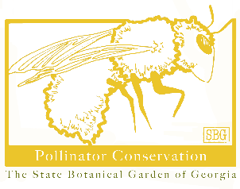**Connect to Protect**

-- Providing habitat in small spaces, one planting at a time --

**Schools, Offices, Museums, Shops, Stores, Cafes, Home and Patio Gardens -- Join Connect to Protect!** Get native plants of Georgia, grown from seeds collected in state, to plant in a garden or large pot.

**A Connect to Protect Garden will:**

**- Provide host plants for insects** native to Georgia! And insects are the only food baby birds eat!

**- Provide a “caterpillar nursery”** for baby moths and butterflies!

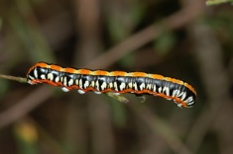**- Provide bird habitat -** hiding places for ground birds, nest material for song birds, and food for adult birds too!

*Cucullia alfarata* larvae live on Maryland Golden Aster plants. Photo by John Pickering, Discoverlife.org

**The goal of Connect to Protect** is to help Georgians create small gardens with native plants to help support Georgia wildlife. Your plantings will connect native plants to their insect partners.

We hope to see these plantings incorporated everywhere - on patios and porches, gardens and veggie patches, schools and campuses, libraries and coffee shops. These native plants support biodiversity in urban spaces.

**Did you know?**

Research has shown that even small plantings help native animal species in urban areas connect.

**Did you know?**

Over 436 species of caterpillar can be found on a Black Cherry Tree.

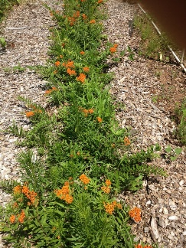**Did you know?**

Some butterflies can only lay their eggs on a few plant species. The Gulf Fritillary uses Passion Vine to host its caterpillars. Monarchs use Milkweed species.

Your Connect to Protect planting will support Georgia’s insects and birds!

By connecting many Connect to Protect plantings across the state, we can help migrating species on their pathways through our state, and we can support species that call our state home.

**Here is how to get started!**

**1.** Submit your Connect to Protect plant package, selecting plants appropriate to your physiographic province and site requirements. See back page.

**2.** Request a visit from an expert. We’ll send a specially trained volunteer, one of our Botanical Guardians, to your site to advise your planting.

**3.** Order your special sign to teach others about how your planting is helping biodiversity in urban areas.

**4.** Register your planting. We are tracking these Connect to Protect gardens across our state.

**5.** Collect data. Send us your observations on the insects and animals that are visiting your planting. And let us know if you need help or have any questions. **Contact:** abiscegl@uga.edu

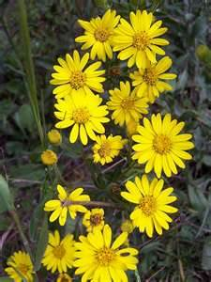**Site requirements:**

● These plants require full sun. The more sun the better.

● These plants require quickly draining soil. Raised beds are great made up of soil amendments like compost, bark, small gravel, sand. If you are planting in a container, use potting soil, adding composted pine bark to your mix.

● Tell us which Physiographic Province you live in to help us select the most appropriate species for your planting.

● We provide plant profiles for each plant species with ecological and horticultural details!

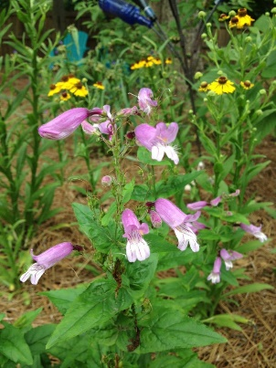**Physiographic province:**

□ Piedmont

□ Mountains

□ Coastal Plain

**Type of planting:**

□ Raised bed

□ Pot

**Woody plant addition (for in-ground plantings only):** □ Tree □ Shrub $12 each

**Expert site visit?**

□ Yes, please. □ No, I got this.

**Planting kit:**

2 native grass species

2 native wildflower species

3 4-inch pots of each species = 12 plants

$60 kit

**Connect to Protect sign:**

□ Yes, please. $25

**Planter (for pick up only):**

$77.50 for 10 gal, planted, gorgeous

**Send in your order:**

abiscegl@uga.edu or mail to

Connect to Protect

SBG Education Department

2450 S. Milledge Avenue

Athens, GA 30605

A limited number of scholarships are available for schools and non-profits.

**Sponsor a school or other planting:**

Give schools or other non-profits Connect to Protect garden! – With this purchase a plant expert will come to your site, help you set it up, advise you on maintenance, and orient you to the wildlife your plants host!”

$60 for planting kit for gardens

$12 for woodies for gardens

$77.50 for planted planter, gorgeous

$25 for Connect to Protect sign

**Register for a School Program:**

An environmental educator from the State Botanical Garden of Georgia will come to your school, create a Connect to Protect planting of your choice, and lead students through related hands-on education activities! Programs cost $4/student plus the cost of a planter as listed above.

**Contact:** abiscegl@uga.edu 706-583-0894

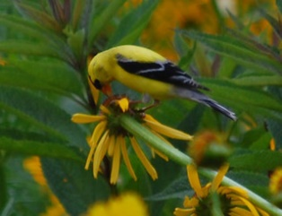**Did you know?**

Goldfinches sit on wildflower heads like Black-eyed Susan, Coneflower, and native Sunflower species and pick out seeds. Photo by Sheryl Pollock, Discoverlife.org

**Did you know?**

Grouse raise and feed their young in native bunch grasses. This is called “bugging and brooding.”

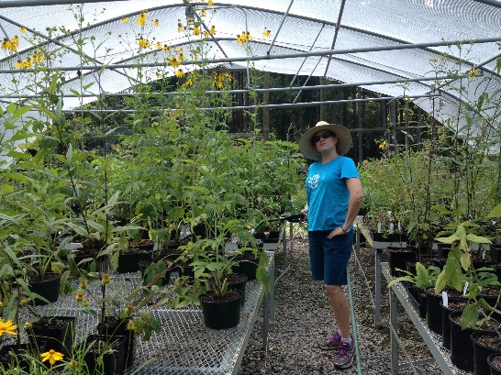

**Connect to Protect**

A Project of the State Botanical Garden of Georgia.

Connect to Protect was inspired by a similar program at Fairchild Tropical Garden. Fall 2013.

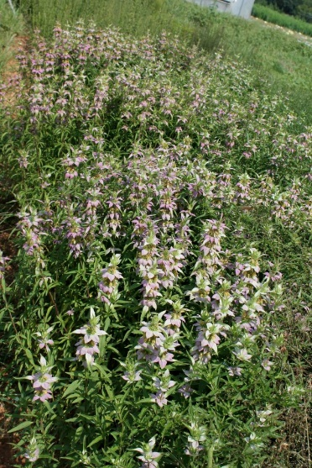**Did you know?**

Humble Bumbles (our native Bumble bees) forage on *Monarda punctat* ,even in the rain!